

**OVERALL DECISION: COMPETENT**

**Excellent. Good work!**

**Formative Assessment**

**Thinking like a machine (115367)**

*Hello and welcome to the assessment. Here you’ll prove to the world just how much you know and understand about what you’ve just learnt in the learner guides. This is an important part of your time at Umuzi because once this is done, you’ll be certified! So please, take this time to learn everything you can! Take a look at some pointers below with regard to answering the questions…*

* *Be specific*
* *Write professionally - no shorthand!*
* *Your answers must be original and come from your brain and your brain only.*
* *No copy/paste tricks! Our markers have seen it all and will know if you’re taking shortcuts.*
* *Remember, sloppy or poor work will be sent back to you to do again, so do it properly the first time and you’ll be done in no time.*
* *Ask for help at any time. Ask your friends, a manager, anybody!!*
* *Don’t skip any questions! You must do them all!*
* *You’ll see two boxes after each question - one for your answer and one for the marker’s comments. DO NOT delete the marker’s comments if you are required to resubmit your work after the first attempt. Should you have to do it again you will see a new box* ***under*** *the marker’s comments, so fill that one out in* ***BLUE****. Remember!! It’s not the end of the world if you have to resubmit. You’re here to learn, so don’t beat yourself up if you don’t get it right on the first go. Obviously, try your best to get it right on the first attempt, but if not, you have another chance to do it properly!*

*Ok, and that’s that! Time to get to it! Good luck, have fun and enjoy! :)*

**Enter your name and surname below**

|  |
| --- |
| **Sinethemba Zulu** |

**1.** **List and describe at least three approaches to start solving a problem (the answers are in the 2nd and 3rd videos on problem solving) [6 Marks](6 SO:1 AC: 1-4) (6 SO:1 AC: 1-4)**

**Your answer below**

|  |
| --- |
| * **Understand✓**   Know exactly what they are looking for. Most difficult problems are difficult because you don't understand them (therefore, this is the first step). **✓**  How do you know when you've got a problem? When do you describe this in plain English? **✓**  Remember to be stuck on a problem, you begin to describe it, and you suddenly see holes in the reasoning that you haven't seen before? **✓**   * **Plan✓**   Do not dive straight into solving without a plan (and hope you can muddle your way through it somehow). Plan the solution you want! **✓**  If you can't figure out the exact steps, nothing can support you. This means you don't start hacking right away while programming. Offer your brain time to process the information and evaluate the question. **✓**   * **Divide✓**   Pay attention. This is the most important step of all. Don't try to solve a big problem. You're going to cry. Instead, you're going to break it into sub-problems. These sub-problems are a lot easier to solve. Then, solve each sub-problem one by one. Begin with the simplest thing. Simplest means that you know the answer (or are closer to that answer). After that, the simplest way this sub-problem is solved doesn't depend on the others being solved.Once you solved every sub-problem, connect the dots.Connecting all your “sub-solutions” will give you the solution to the original problem. **✓** |

**Marker’s Comments**

|  |
| --- |
| **Correct** |

**2. What number do you think should go inside the final triangle from the first section of the reading? Describe the logic you used to reach your conclusion. [4 Marks](4 SO:1 AC:1-4)**

**Your answer below**

|  |
| --- |
| It will be 3.Triangle 1 ( 2x6) - (2x2) = 8 ; Triangle 2 (3x7) - (3x5) = 6 ; Triangle 3 (2x7) - (2x4) = 6 ; Triangle 4 (3x6) - (3x5) = 3**✓** |

**Marker’s Comments**

|  |
| --- |
| **Correct** |

**3. Describe how each of the following logic gates work [7 Marks](7 SO: 2 AC: 1-4)**

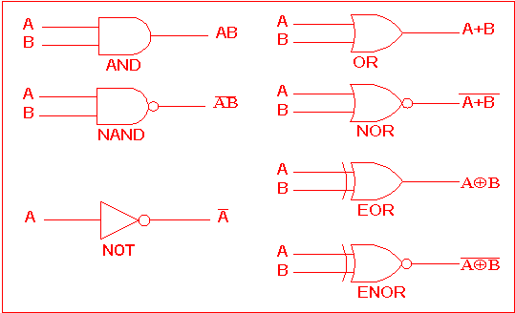

**Your answer below**

|  |
| --- |
| Logic gates work as follows:  **AND GATE**-The output is only true if and only if all inputs are True then the output is False **✓**  **OR GATE**-the output is true if at least one input is True then the output would be false. **✓**  **NAND GATE** is the opposite of **AND GATE**, which means that it takes the opposite of **AND GATE** output. **✓**  **NOR GATE** is the opposite of **OR GATE**, which means that it takes the opposite of the output of **OR GATE. ✓**  **NOT GATE** the output is always the opposite of an input. E.g if True is our input then the output will be False. **✓**    The '**Exclusive-OR**' gate is a circuit which will give a high output if either, but not both, of its two inputs are high. An encircled plus sign () is used to show the **EOR** operation. **✓**    The **'Exclusive-NOR**' gate circuit does the opposite to the **EOR** gate. It will give a low output if either, but not both, of its two inputs are high. The symbol is an **EXOR** gate with a small circle on the output. The small circle represents inversion. **✓** |

**Marker’s Comments**

|  |
| --- |
| **Correct** |

**4. List the seven laws of Boolean algebra [7 Marks](7 SO: 3 AC: 1)**

**Your answer below**

|  |
| --- |
| * Annulment Law**✓** * Identity Law**✓** * Idempotent Law**✓** * Complement Law**✓** * Commutative Law**✓** * Double Negation Law**✓** * de Morgan´s Theorem**✓** |

**Marker’s Comments**

|  |
| --- |
| **Correct** |